**CURRICULUM VITAE**

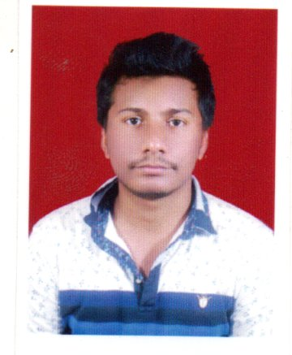**Mr. Siba Sankar Sahu**

**Phone: 8917412959**

**Email:** [**sahusibasankar28@gmail.com**](mailto:sahusibasankar28@gmail.com)

**Address: P.T.S Road , Nayagarh**

**Odisha, India**

**Pin:752069**

**CAREER OJECTIVE**

To have a growth oriented and challenging career, where I can contribute my knowledge and skills for betterment of the organization and enhance my experience through continuous learning and teamwork.

**EDUCATIONAL QUALIFICATION**

* Completed B.Tech in **Mechanical Engineering from Kalam Institute Of Technology, Berhampur under B.P.U.T, Odisha** in the year **2016.**
* Completed Intermediate in Science stream in the year **2012** from **Itamati College of Edn & Tech, Itamati** under **C.H.S.E, Odisha.**
* Completed 10th in the year **2010** from **Saraswati sishu Vidya Mandir, Nayagarh under B.S.E Odisha.**

**PROFESSIONAL CERTIFICATION**

* Post-Graduation Program in Life Insurance From“**UPGRAD”** In Between (February 3, 2020 – March 31, 2021).

**WORK EXPERIENCE**

* Working as a **CAM** in “**HDFC LIFE”** in Banc-assurance Channel (HDFC BANK) From August 2020- Present).

**WORK PROFILE**

* Dealing with HNI customers.
* Maintaining relationship with Bank Employees.
* Cross selling products like Term ,Traditional and Ulip plans.

**COMPUTER SKILLS**

* Post graduate diploma in computer application (PGDCA)
* Operating system: Windows XP, 7, 8, 10.

**AREAS OF INTERST**

* Tech support.
* Like to keep myself update with all the current affairs.
* Learning new things in daily basis.
* Listening music and Photography.

**PROJECT**

* **“Design and operation of pedal driven power hacksaw”.**
* **“Study of a steam condenser in power plant system”.**

**INDUSTRIAL VISIT**

* One month **“Internship”** at **National Aluminum Company (NALCO), Angul.**

**PERSONAL TRAIT**

* Creative and logical.
* Problem solving ability.

**LANGUAGE KNOWN**

* English, Hindi and odia (Read and write).

**DECLARATION**

* I hereby declare that all the details given here are true to the best of my knowledge.

Date: 17/05/2021

Place: Nayagarh Candidate’s Signature